**MINISTRY OF EDUCATION**

**AND TRAINING**

**FPT UNIVERSITY**

Capstone Project Document

Distribution Management System in pharmaceutical

Report #3 – Software Requirement Specification

|  |  |
| --- | --- |
| Distribustion Management System in Pharmaceutial | |
| Group Members | Trương Võ Thiên Vũ – Team Leader – SE60626  Tạ Đức Tùng – Team Member – 60416  Nguyễn Trần Hoàng Quý – Team Member – 60356  Nguyễn Trọng Việt – Team Member – SE02406 |
| Supervisor | Nguyễn Văn Sang |
| Capstone Project code | DMS |

- Ha Noi, 09/2015 –

Contents

3.1. User Requirement Specification 3

3.1.1. Functional Requirements 3

3.1.2. Non-Functional Requirements 4

3.2. System Requirement Specification (Specific Requirements) 5

3.2.1. External Interface Requirements 5

3.2.2. Functional Requirements 6

3.2.3. Non-functional Requirements 72

3.3. Entity Relationship Diagram 73

## User Requirement Specification

### Functional Requirements

#### Guest Requiremens

**Guest is an unauthorized user of website. Guest have to:**

* Login with thier authorized account.
* Register new account.
* View, search drugs.
* View details drug.

#### Authorized User Requirements

**An Authorized user can:**

* Log out.
* Change their password.
* View and update their account details.

#### Customer Requirement

**Customer is a logged user and has all function of a logged user. In addition, they have all function of Guest except Login and Register function. Customer also has their own function**

* Create drugs orders.
* Search and view details drugs.
* View history payment of orders.
* View history orders.

#### Staff Requirement

**Staff is a logged user and have all function of logged user. In addition, a system Staff also has their function:**

* Manage all order: approve, reject online orders.
* Manage schedule: create and detele schedules.
* Manage drus: create, edit, delete drugs.
* Manage drugstores: create, edit, delete drugs, import drugstore from excel files, assign Drugstore to Salesman.

#### Salesman Requirement

**Salesman is a logged user and have all function of a logged user. In addition, a system Salesman also has their function:**

* Create order for Drugstore managed by themselves.
* Verify Drugstores.
* View all orders of Drugstores.

#### Administrator Requirement

**Administrator is a logged user and have all function of logged user. In addition, Administrator have their function:**

* Manage all user: Deactivate and Activate user, edit user details, delete account.

### Non-Functional Requirements

Distribution Management System in pharmaceutial (DMS) is an public website, which allows Drugstore order drug from Company easily.

* + - **Reliability**: Information about drug are provided by Staff in such a way that preserves the most accurate and up-to-date data. (Mức độ tin cậy thể hiện qua thời gian, tỉ lệ lỗi)
    - **Security**: Authentication is required when the user utilizes certain function in system. Password must be encrypted so the even they are unrecognizable even to System Administrator and Database Administrator. System should also require authorization when user tries to access an unauthorized function.
    - **Maintainability**: In the architecture design of the system, the responsibilities of all component should be clear and do not overlap each other. The communication with a web service provider should be packaged in single module independent from the rest of the system. The module should support plug-and-play, so when the web service provider change the structure of web service result, or when system work with other web service provider. Minimal changes to rest of system are required.
    - **Portability**: On the client side, website should be accessible to anyone with a personal computer that connected to the Internet and also has a browser.

## System Requirement Specification (Specific Requirements)

### External Interface Requirements

#### User Interfaces

The DMS website should adopt an attractive and user-friendly interface so that the users of the system can get a good experience browsing the site.

The page should be well linked together to promote seamless navigation between them. The instructions should be specific and suggestive, so that the users will not be confused about what to do next

Client postbacks should be limited wherever possible, in oder to perfomance and easy of use.

Vietnamese should be the official language of website as its target customer are mainly Vietnamese market. Vietnam Dong should be officical currency. Moreover, all other localizable information, such as date and time, shoud be Vietnamese-styled.

### Functional Requirements

#### Function List

##### List of User

|  |  |
| --- | --- |
| Term | Description |
| Guest | Who not logged in System |
| Authorized User | Who logged in System |
| Drug Store | Who logged in System with Drug Store roll |
| Staff | Who logged in System with Staff roll |
| Administrator | Who logged in Sytem with Admin roll |

#### Overview Use-Case Diagram

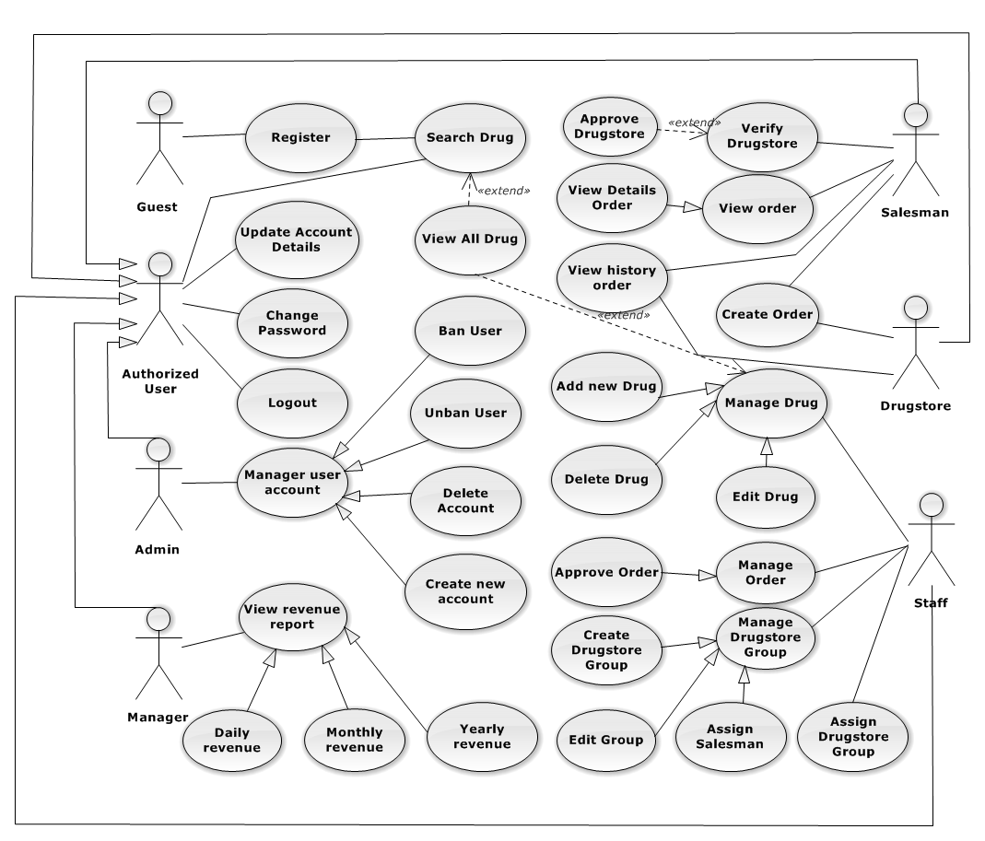

**Figure 3-1: Overview Use-Case Diagram**

#### Use-Case list ( thêm một cột description)

|  |  |  |  |
| --- | --- | --- | --- |
| Use-Case ID | Actor | Use-Case | Description |
| UC0001 | Guest | Register | Guest register new account in System. |
| UC0002 | Guest | Login | Guest login with an Authenticated User. |
| UC0003 | Guest | Forgot Password | Support User get a new Password. |
| UC0004 | Guest | Search Drug | Support User search Drug in System. |
| UC0005 | Guest | View Drug Detail | Support User view Drug’s information. |
| UC0006 | Guest | View all Drug | Support User view all Drug in System. |
| UC0007 | Authorized User | Search Drug | Support User search Drug in System. |
| UC0008 | Authorized User | View all Drug | Support User view all Drug in System. |
| UC0009 | Authorized User | Update profile | Support User update their information. |
| UC0010 | Authorized User | Change Password | Support User changer their password. |
| UC0011 | Authorized User | Logout | Support User logout of System. |
| UC0012 | Drug Store | Create Order | Support Drugstore Create Order. |
| UC0013 | Drug Store | View Order history | Support Drugstore view their history order. |
| UC0014 | Drug Store | View Payment history | Support Drugstore view their history payment. |
| UC0015 | Drug Store | Cancel Order | Support Drugstore cancel their Order. |
| UC0016 | Salesman | Verify Drugstore | Salesman verify what kind of Drugstore. |
| UC0017 | Salesman | Create Order | Salesman Create Order for Drugstore. |
| UC0018 | Salesman | View Order | View all Order from Drugstore. |
| UC0019 | Salesman | View Order Detail | View Detail of an Order. |
| UC0020 | Salesman | Set Discount Rate | Salesman set Discount rate for Drugstore. |
| UC0021 | Staff | Approve Order | Confirm Order request from Drugstore. |
| UC0022 | Staff | Add New Drug | Staff add new Drug to System. |
| UC0023 | Staff | Delete Drug | Staff delete a Drug from System. |
| UC0024 | Staff | Edit Drug | Staff Edit detail of Drug (price, status…) |
| UC0025 | Staff | Assign Salesman | Assign salesman to their group they manage. |
| UC0026 | Staff | Create Category | Staff can Create a new category of Drug. |
| UC0027 | Staff | Delete Category | Staff can Delete a category of Drug. |
| UC0028 | Staff | Edit Category | Staff can Edit a category of Drug. |
| UC0029 | Staff | Create Delivery Schedule | Staff create Delivery schedule for Deliveryman. |
| UC0030 | Staff | Update Delivery Status | Staff update Delivery status to System. |
| UC0031 | Administrator | Create new account | Admin can create new account for Manager, Staff, Salesman. |
| UC0032 | Administrator | Deactivate account | Admin can deactivate all active account in System. |
| UC0033 | Administrator | Activate account | Admin can activate all deactivate account in System. |

#### UC0001 “Guest” Register (Vẽ thành nhóm chức năng, đánh dấu số usecase ở tiêu đề)

##### Use-Case Diagram

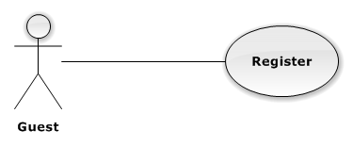

**Figure 3-2: Register Use-Case Diagram**

##### Use-Case Specification

|  |  |  |  |
| --- | --- | --- | --- |
| USE CASE SPECIFICATION | | | |
| Use-case No. | UC0001 | Use-case Version | 1.0 |
| Use-case Name | Register | | |
| Author | TungTD | | |
| Date | 10/10/2015 | Priority | Normal |
| Actor:  Guest.  Summary:  This Use Case help Guest to create an account in the system.  **Goal:**  Help Guest can have an account in the system. Guest can use this account to login the system and post their request.  Triggers:  Guest go to [Trang chủ] and click on “Tạo tài khoản” link.  Preconditions:  Guest does not have an account in system.  Post Conditions:  User Homepage display.  Main Success Scenario:   |  |  |  | | --- | --- | --- | | Step | Actor | Action | | 1 | User | Guest go to [Trang chủ] and clicks on [Đăng Kí] button. | | 2 | System | Display [Đăng ký] screen with text box for guest input all necessary to create new account. | | 3 | User | Input all required field. | | 4 | System | Validate all input date. Send error message (if have invalid data). | | 5 | User | Guest click on [Đồng ý] button (Correct all invalid fields if have any invalid data). | | 6 | System | System creates new account for guest. | | 7 | System | Redirect to [Trang chủ]. |   Alternative Scenario:   |  |  |  | | --- | --- | --- | | # | Actor | Action | | 1 | User | Click on [Hủy] button | | System | System redirect to [Trang chủ] |   Exceptions:   |  |  |  | | --- | --- | --- | | # | User | System | | 1 | User | Not input enough information required | | System | Display message error: “Vui lòng điền thông tin vào những ô bắt buộc” |   Relationships:  “Login” use case.  Business Rules:   |  |  | | --- | --- | | # | Business Rule Description | | 1 | Guest must be enter all required fields before submitting. | | 2 | Each register, guest can create one account in the system | | 3 | Each Drugstore’s info, there is only one account. | | 4 | Each account in the system is distinguished by e-mail address. | | 5 | When e-mail fields of the new account are the same as the existing ones, system will show invalid message. | | | | |

#### UC0002 “Guest” Login

##### Use-Case Diagram

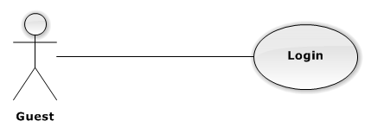

**Figure 3-3: Login Use-Case Diagram**

##### Use-Case Specification

|  |  |  |  |
| --- | --- | --- | --- |
| USE CASE SPECIFICATION | | | |
| Use-case No. | UC0002 | Use-case Version | 1.0 |
| Use-case Name | Login | | |
| Author | Tạ Đức Tùng | | |
| Date | 09/10/2015 | Priority | Normal |
| Actor:  Guest.  Summary:  This use case allows authorized user login to the system.  **Goal:**  Authenticate user.  Triggers:  User access website area that is Authorized User.  Preconditions:  User has an account and has not logged in yet.  Post Conditions:  ***On Success****:* User logged in. System redirects user to User Homepage.  ***On Failure****:* System redirects to “Login” page.  Main Success Scenario:   |  |  |  | | --- | --- | --- | | Step | Actor | Action | | 1 | User | User go to website page press [Đăng nhập] button. | | 2 | System | Website display [Login] page. | | 3 | User | User input information into username field and password field | | 4 | User | Presses [Đăng nhập] button or click [Enter] key. | | 5 | System | Check username and password. | | 6 | System | Redirect to User Homepage. |   Alternative Scenario:  N/A  Exceptions:   |  |  |  | | --- | --- | --- | | # | Actor | Action | | 1 | User | Presses [Login] button. If invalid username or password. | | 2 | System | System redirect to [Login] page and display error message “Tên đăng nhập hoặc mật khẩu không đúng!” | | 3 | User | Presses [Login] button. If have error when connect database | | 4 | System | System redirect to “Login” page and display error message “Lỗi kết nối đến máy chủ!” |   Relationships:  N/A  Business Rules:   |  |  | | --- | --- | | # | Business Rule Description | | 1 | Needed Internet Connection. | | | | |

#### “Guest” UC0003 Forgot Password

##### Use-Case Diagram

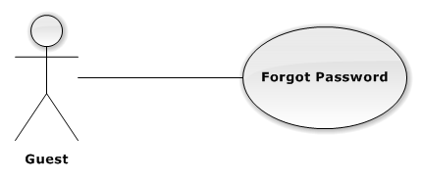

**Figure 3-4: Forgot Password Use-Case Diagram**

##### Use-Case Specification

|  |  |  |  |
| --- | --- | --- | --- |
| USE CASE SPECIFICATION | | | |
| Use-case No. | UC0003 | Use-case Version | 1.0 |
| Use-case Name | Logout | | |
| Author | Tạ Đức Tùng | | |
| Date | 09/10/2015 | Priority | Normal |
| Actor:  Guest.  Summary:  This use case allow authenticate user get new password.  **Goal:**  Support Authenticate User get new Password.  Triggers:  User click on “Quên mật khẩu” on [Login] Page.  Preconditions:  User has an account in System.  Post Conditions:  ***On Success:*** Redirect to login screen.  ***On Failure:*** An error message is displayed.  Main Success Scenario:   |  |  |  | | --- | --- | --- | | Step | Actor | Action | | 1 | User | User click [Xác Nhận] button on [LostPassword] Page | | 2 | System | Display Successful message and redirect to [Login] Page. |   Alternative Scenario:  N/A  Exceptions:  N/A  Relationships:  N/A  Business Rules:   |  |  | | --- | --- | | # | Business Rule Description | | 1 | Needed Internet Connection. | | | | |

#### UC0004 “Guest” Search Drug

##### Use-Case Diagram

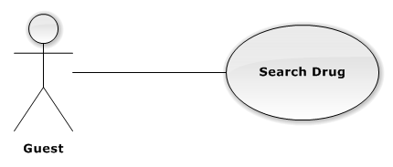

**Figure 3-5: Search Drug Use-Case Diagram**

##### Use-Case Specification

|  |  |  |  |
| --- | --- | --- | --- |
| USE CASE SPECIFICATION | | | |
| Use-case No. | UC0004 | Use-case Version | 1.0 |
| Use-case Name | Search Drug | | |
| Author | TungTD | | |
| Date | 10/10/2015 | Priority | Normal |
| Actor:  Guest, Authorized User.  Summary:  This Use Case help Guest to Find Drug in System.  **Goal:**  Help User can find a Drug that they know the name easier.  Triggers:  Guest go to Homepage and Input name of Drug in textbox.  Preconditions:  User is in System.  Post Conditions:  Drug display on Search Screen.  Main Success Scenario:   |  |  |  | | --- | --- | --- | | Step | Actor | Action | | 1 | User | Fill Drug name in textbox and press [Search] button | | 2 | System | Show Drug if exists in database. |   Alternative Scenario:  N/A  Exceptions:   |  |  |  | | --- | --- | --- | | Step | Actor | Action | | 1 | User | Fill Drug name in textbox and press [Search] button | | 2 | System | Display message “Không có loại thuốc nào”. |   Relationships:  N/A  Business Rules:   |  |  | | --- | --- | | # | Business Rule Description | | 1 | Needed Internet Connection. | | | | |

#### UC0005 “Guest” View Drug Detail

##### Use-Case Diagram

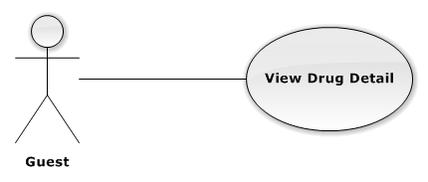

**Figure 3-6: View Drug Detail Use-Case Diagram**

##### Use-Case Specification

|  |  |  |  |
| --- | --- | --- | --- |
| USE CASE SPECIFICATION | | | |
| Use-case No. | UC0005 | Use-case Version | 1.0 |
| Use-case Name | Register | | |
| Author | TungTD | | |
| Date | 10/10/2015 | Priority | Normal |
| Actor:  Authorized User, Guest  Summary:  This Use Case help User view Detail of each Drug.  **Goal:**  Help User know detail of Drug, price, status, effect.  Triggers:  Guest go to Homepage and click on Drug’s image.  Preconditions:  User were in Homepage.  Post Conditions:  Drug’s Detail page Display.  Main Success Scenario:   |  |  |  | | --- | --- | --- | | Step | Actor | Action | | 1 | User | Guest go to [Homepage] and clicks on any [Drug] Product. | | 2 | System | Display [DrugDetail] screen. |   Alternative Scenario:  N/A  Exceptions:  N/A  Relationships:    Business Rules:   |  |  | | --- | --- | | # | Business Rule Description | | 1 | Needed Internet Connection. | | | | |

#### UC0006 “Guest” View all Drug

##### Use-Case Diagram

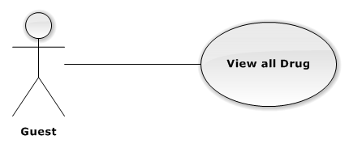

**Figure 3-7: View all Drug Use-Case Diagram**

##### Use-Case Specification

|  |  |  |  |
| --- | --- | --- | --- |
| USE CASE SPECIFICATION | | | |
| Use-case No. | UC0006 | Use-case Version | 1.0 |
| Use-case Name | View all Drug | | |
| Author | TungTD | | |
| Date | 10/10/2015 | Priority | Normal |
| Actor:  Guest. Authorized User  Summary:  This Use Case help user can view all Drug in system.  **Goal:**  Help user can view all Drug of company.  Triggers:  Guest go to Homepage and Press “Xem toàn bộ thuốc”.  Preconditions:  User in Hompage.  Post Conditions:  Display list all Drug Product.  Main Success Scenario:   |  |  |  | | --- | --- | --- | | Step | Actor | Action | | 1 | User | Press on “Xem toàn bộ” button | | 2 | System | Show All Drug exists in database. |   Alternative Scenario:  N/A  Exceptions:  N/A  Relationships:  N/A.  Business Rules:   |  |  | | --- | --- | | # | Business Rule Description | | 1 | Needed Internet Connection. | | | | |

#### UC0007 “Authorized User” Search Drug

##### Use-Case Diagram

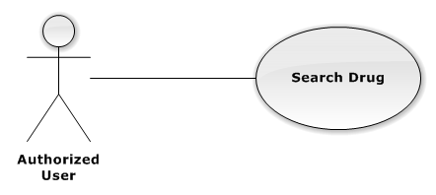

**Figure 3-8: Search Drug Use-Case Diagram**

##### Use-Case Specification

|  |  |  |  |
| --- | --- | --- | --- |
| USE CASE SPECIFICATION | | | |
| Use-case No. | UC0007 | Use-case Version | 1.0 |
| Use-case Name | Search Drug | | |
| Author | TungTD | | |
| Date | 10/10/2015 | Priority | Normal |
| Actor:  Guest, Authorized User.  Summary:  This Use Case help Guest to Find Drug in System.  **Goal:**  Help User can find a Drug that they know the name easier.  Triggers:  Guest go to Homepage and Input name of Drug in textbox.  Preconditions:  User is in System.  Post Conditions:  Drug display on Search Screen.  Main Success Scenario:   |  |  |  | | --- | --- | --- | | Step | Actor | Action | | 1 | User | Fill Drug name in textbox and press Search button | | 2 | System | Show Drug if exists in database. |   Alternative Scenario:  N/A  Exceptions:   |  |  |  | | --- | --- | --- | | Step | Actor | Action | | 1 | User | Fill Drug name in textbox and press Search button | | 2 | System | Display message “Không có loại thuốc nào”. |   Relationships:  N/A  Business Rules:   |  |  | | --- | --- | | # | Business Rule Description | | 1 | Needed Internet Connection. | | | | |

#### UC0008 “Authorized User” View All Drug

##### Use-Case Diagram

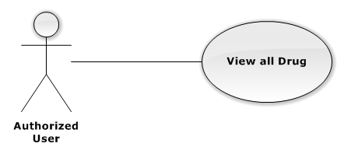

**Figure 3-9: View all Drug Use-Case Diagram**

##### Use-Case Specification

|  |  |  |  |
| --- | --- | --- | --- |
| USE CASE SPECIFICATION | | | |
| Use-case No. | UC0006 | Use-case Version | 1.0 |
| Use-case Name | View all Drug | | |
| Author | TungTD | | |
| Date | 10/10/2015 | Priority | Normal |
| Actor:  Guest. Authorized User  Summary:  This Use Case help user can view all Drug in system.  **Goal:**  Help user can view all Drug of company.  Triggers:  Guest go to Homepage and Press “Xem toàn bộ thuốc”.  Preconditions:  User in Hompage.  Post Conditions:  Display list all Drug Product.  Main Success Scenario:   |  |  |  | | --- | --- | --- | | Step | Actor | Action | | 1 | User | Press on “Xem toàn bộ” button | | 2 | System | Show All Drug exists in database. |   Alternative Scenario:  N/A  Exceptions:  N/A  Relationships:  N/A.  Business Rules:   |  |  | | --- | --- | | # | Business Rule Description | | 1 | Needed Internet Connection. | | | | |

#### UC0009 “Authorized User” Update Profile

##### Use-Case Diagram

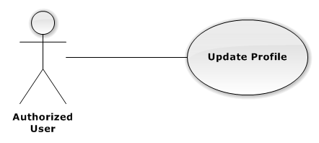

**Figure 3-10: Update Profile Use-Case Diagram**

##### Use-Case Specification

|  |  |  |  |
| --- | --- | --- | --- |
| USE CASE SPECIFICATION | | | |
| Use-case No. | UC0001 | Use-case Version | 1.0 |
| Use-case Name | Register | | |
| Author | TungTD | | |
| Date | 10/10/2015 | Priority | Normal |
| Actor:  Guest.  Summary:  This Use Case help Guest to create an account in the system.  **Goal:**  Help Guest can have an account in the system. Guest can use this account to login the system and post their request.  Triggers:  Guest go to Homepage and click on “Tạo tài khoản” link.  Preconditions:  Guest does not have an account in system.  Post Conditions:  User Homepage display.  Main Success Scenario:   |  |  |  | | --- | --- | --- | | Step | Actor | Action | | 1 | User | Guest go to Homepage and clicks on “Đăng Kí” | | 2 | System | Display “Register” screen with text box for guest input all necessary to create new account | | 3 | User | Input all required field | | 4 | System | Validate all input date. Send invalid message (if have invalid data) | | 5 | User | Guest click on “Đồng ý” button (Correct all invalid fields if have any invalid data) | | 6 | System | System creates new account for guest | | 7 | System | Redirect to User Homepage |   Alternative Scenario:   |  |  |  | | --- | --- | --- | | # | Actor | Action | | 1 | User | Click on “Hủy” button | | System | System redirect to Homepage |   Exceptions:   |  |  |  | | --- | --- | --- | | # | User | System | | 1 | User | Not input enough information required | | System | Display message error: “Vui lòng điền thông tin vào những ô bắt buộc” |   Relationships:  “Login” use case.  Business Rules:   |  |  | | --- | --- | | # | Business Rule Description | | 1 | Guest must be enter all required fields before submitting. | | 2 | Each register, guest can create one account in the system | | 3 | Each Drugstore’s info, there is only one account. | | 4 | Each account in the system is distinguished by e-mail address. | | 5 | When e-mail fields of the new account are the same as the existing ones, system will show invalid message. | | | | |

#### UC0010 “Authorized User” Change Password

##### Use-Case Diagram

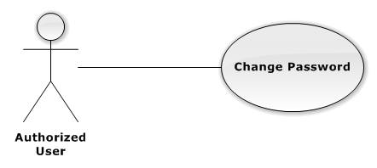

**Figure 3-11: Change Password Use-Case Diagram**

##### Use-Case Specification

|  |  |  |  |
| --- | --- | --- | --- |
| USE CASE SPECIFICATION | | | |
| Use-case No. | UC0010 | Use-case Version | 1.0 |
| Use-case Name | Change Password | | |
| Author | Tạ Đức Tùng | | |
| Date | 09/10/2015 | Priority | Normal |
| Actor:  Authorized User.  Summary:  This use case allows authorized user can change password of them.  **Goal:**  Change password.  Triggers:  User access website area and click on “Đổi mật khẩu”.  Preconditions:  User has logged in.  Post Conditions:  **Success**: The password is changed and display message “Cập nhật mật khẩu thành công!”  **Failure**: Password is not changed. Display error message.  Main Success Scenario:   |  |  |  | | --- | --- | --- | | Step | Actor | Action | | 1 | User | Press on “Thay đổi mật khẩu” in User Control Panel. | | 2 | System | Display Change Password Screen. | | 3 | User | Input all required field. | | 4 | System | Check all required field. | | 5 | User | Press on “Xác nhận” button. | | 6 | System | Display successful message “Thay đổi mật khẩu thành công” |   Alternative Scenario:   |  |  |  | | --- | --- | --- | | *#* | Actor | Action | | 1 | User | Click on “Hủy” button | | 2 | System | Redirect to User Homepage. |   Exceptions:   |  |  |  | | --- | --- | --- | | *#* | Actor | Action | |  | User | Field “Mật khẩu cũ” are blank. | | System | Shows error message “Hãy nhập lại mật khẩu cũ”. | | User | Field “Mật khẩu mới”, are blank | | System | Shows error message “Hãy nhập mật khẩu mới” | | User | Field “Lặp lại mật khẩu mới ” are blank | | System | Shows error message “Hãy nhập lại mật khẩu mới” | | User | Input to field “Mật khẩu cũ”, “Mật khẩu mới” and field “Lặp lại mật khẩu mới” regular expression. | | System | Shows error message “Mật khẩu không được có kí tự đặc biệt” | | User | Input to field “Mật khẩu mới ” and field “Lặp lại mật khẩu mới ” not enough 6 character | | System | Shows error message “Mật khẩu mới phải có ít nhất 6 kí tự” | | User | Input to field “Mật khẩu mới ” and field “Lặp lại mật khẩu mới ” are diffirent | | System | Shows error message “Mật khẩu 2 không trùng khớp” | | User | Input to field “Mật khẩu cũ” not the same with database | | System | Shows error message “Mật khẩu cũ không đúng!”. |   Relationships:  N/A  Business Rules:   |  |  | | --- | --- | | # | Business Rule Description | | 1 | Needed Internet Connection. | | | | |

#### UC0011 “Authorized User” Logout

##### Use-Case Diagram

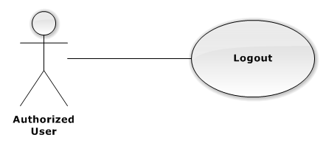

**Figure 3-12: Logout Use-Case Diagram**

##### Use-Case Specification

|  |  |  |  |
| --- | --- | --- | --- |
| USE CASE SPECIFICATION | | | |
| Use-case No. | UC0011 | Use-case Version | 1.0 |
| Use-case Name | Logout | | |
| Author | TungTD | | |
| Date | 10/10/2015 | Priority | Normal |
| Actor:  Authorized User.  Summary:  This Use Case help Authorized User log out of system.  **Goal:**  Help Authorized User can log out of system.  Triggers:  Authorized User Press “Đăng xuất” on User Control Panel.  Preconditions:  User has logged in the System.  Post Conditions:  Redirect to Homepage.  Main Success Scenario:   |  |  |  | | --- | --- | --- | | Step | Actor | Action | | 1 | User | Press “Đăng xuất” on User Control Panel | | 2 | System | End session of User and redirect to Homepage |   Alternative Scenario:  N/A  Exceptions:  N/A  Relationships:  N/A  Business Rules:   |  |  | | --- | --- | | # | Business Rule Description | | 1 | User must be logged in System. | | 2 | Needed Internet Access. | | | | |

#### UC0012 “Drugstore” Create Order

##### Use-Case Diagram

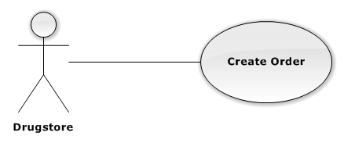

**Figure 3-13: Create Order Use-Case Diagram**

##### Use-Case Specification

|  |  |  |  |
| --- | --- | --- | --- |
| USE CASE SPECIFICATION | | | |
| Use-case No. | UC0012 | Use-case Version | 1.0 |
| Use-case Name | Create Order | | |
| Author | TungTD | | |
| Date | 10/10/2015 | Priority | Normal |
| Actor:  Drugstore.  Summary:  This Use Case allow Drugstore make order to Company.  **Goal:**  Drug can make Order.  Triggers:  Drugstore want to make Order.  Drugstore click on “Tạo đơn hàng” or Cart icon.  Preconditions:  User has logged in with Drugstore role.  Account has been approve in System.  Post Conditions:  *Success:* Order will be marked, pending for Confirm.  *Failure:* Show error message, required to do again.  Main Success Scenario:   |  |  |  | | --- | --- | --- | | Step | Actor | Action | | 1 | User | Guest login with Drugstore role. | | 2 | System | Redirect to User Homepage | | 3 | User | Click on “Tạo đơn hàng” | | 4 | System | Display “Show Cart” screen with a textbox for customer to enter drugstore name. A table content all drugs’s information will be order. | | 5 | User | Choose Drug want to order. | | 6 | System | Valid all input data. | | 7 | User | Click on “Đặt hàng” button. | | 8 | System | Create new pending Order. |   Alternative Scenario:   |  |  |  | | --- | --- | --- | | # | Actor | Action | | 1 | User | Click on “Hủy” button | | System | System redirect to Homepage |   Exceptions:   |  |  |  | | --- | --- | --- | | # | User | System | | 1 | User | Not input enough information required | | System | Display message error: “Vui lòng điền thông tin vào những ô bắt buộc” |   Relationships:  “Login” use case.  Business Rules:   |  |  | | --- | --- | | # | Business Rule Description | | 1 | Drugstore must be enter all required fields before submitting. | | 2 | Needed Interned Access. | | | | |

#### UC0013 “Drugstore” View Order history

##### Use-Case Diagram

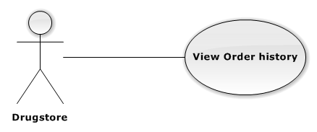

**Figure 3-14: View Order history Use-Case Diagram**

##### Use-Case Specification

|  |  |  |  |
| --- | --- | --- | --- |
| USE CASE SPECIFICATION | | | |
| Use-case No. | UC0013 | Use-case Version | 1.0 |
| Use-case Name | Register | | |
| Author | TungTD | | |
| Date | 10/10/2015 | Priority | Normal |
| Actor:  Drugstore.  Summary:  This Use Case help Drugstore view their history Order.  **Goal:**  Drugstore can view all history Order.  Triggers:  Drugstore click on “Lịch sử đơn hàng” on User Control Panel.  Preconditions:  User has logged in with Drugstore role.  Post Conditions:  Show all history Order.  Main Success Scenario:   |  |  |  | | --- | --- | --- | | Step | Actor | Action | | 1 | User | Click on “Lịch sử đơn hàng” on User Control Panel | | 2 | System | Display all Order history |   Alternative Scenario:  N/A  Exceptions:  N/A  Relationships:  N/A  Business Rules:   |  |  | | --- | --- | | # | Business Rule Description | | 1 | User has logged in with Drugstore role. | | 2 | Needed Internet Access. | | | | |

#### UC0014 “Drugstore” View Payment history

##### Use-Case Diagram

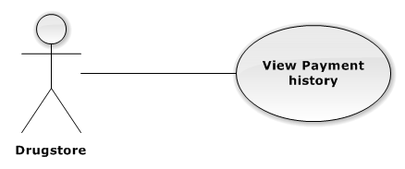

**Figure 3-15: View Payment history Use-Case Diagram**

##### Use-Case Specification

|  |  |  |  |
| --- | --- | --- | --- |
| USE CASE SPECIFICATION | | | |
| Use-case No. | UC0014 | Use-case Version | 1.0 |
| Use-case Name | View Payment history | | |
| Author | TungTD | | |
| Date | 10/10/2015 | Priority | Normal |
| Actor:  Drugstore.  Summary:  This Use Case help Drugstore view their history Payment.  **Goal:**  Drugstore can view all history Payment.  Triggers:  Drugstore click on “Lịch sử thanh toán” on User Control Panel.  Preconditions:  User has logged in with Drugstore role.  Post Conditions:  Show all history Payment.  Main Success Scenario:   |  |  |  | | --- | --- | --- | | Step | Actor | Action | | 1 | User | Click on “Lịch sử thanh toán” on User Control Panel | | 2 | System | Display all Payment history |   Alternative Scenario:  N/A  Exceptions:  N/A  Relationships:  N/A  Business Rules:   |  |  | | --- | --- | | # | Business Rule Description | | 1 | User has logged in with Drugstore role. | | 2 | Needed Internet Access. | | | | |

#### UC0015 “Drugstore” Cancel Order

##### Use-Case Diagram

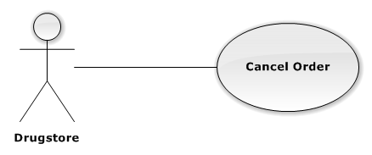

**Figure 3-16: Cancel Order Use-Case Diagram**

##### Use-Case Specification

|  |  |  |  |
| --- | --- | --- | --- |
| USE CASE SPECIFICATION | | | |
| Use-case No. | UC0015 | Use-case Version | 1.0 |
| Use-case Name | Cancel Order | | |
| Author | TungTD | | |
| Date | 10/10/2015 | Priority | Normal |
| Actor:  Drugstore.  Summary:  This Use Case help Drugstore Cancel their Order.  **Goal:**  Help Drugstore can cancel Order with any reasons.  Triggers:  User go to Order History Page.  Preconditions:  User logged in with Drugstore role.  Drugstore has at least 1 pending Order.  Post Conditions:  *On Success:* Cancel Order Successful.  *On Failure:* Cancel fail because Order be Confirmed.  Main Success Scenario:   |  |  |  | | --- | --- | --- | | Step | Actor | Action | | 1 | User | Click on “Lịch sử hàng”. | | 2 | System | Display Order history Screen. | | 3 | User | Click on “Hủy” button at right side of Order. | | 4 | System | Cancel Order and Change Status |   Alternative Scenario:  N/A  Exceptions:   |  |  |  | | --- | --- | --- | | # | User | System | | 1 | User | Click on “Hủy đơn hàng” | | System | Display message error: “Đơn hàng này đã được xác nhận nên không thể hủy” |   Relationships:  N/A  Business Rules:   |  |  | | --- | --- | | # | Business Rule Description | | 1 | User has logged in with Drugstore role. | | 2 | Needed Internet Access. | | 3 | There are least 1 Pending Order. | | | | |

#### UC0016 “Salesman” Verify Drugstore

##### Use-Case Diagram

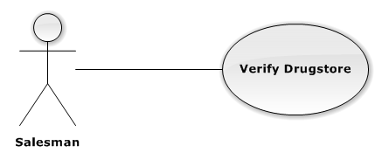

**Figure 3-17: Verify Drugstore Use-Case Diagram**

##### Use-Case Specification

|  |  |  |  |
| --- | --- | --- | --- |
| USE CASE SPECIFICATION | | | |
| Use-case No. | UC0001 | Use-case Version | 1.0 |
| Use-case Name | Register | | |
| Author | TungTD | | |
| Date | 10/10/2015 | Priority | Normal |
| Actor:  Guest.  Summary:  This Use Case help Guest to create an account in the system.  **Goal:**  Help Guest can have an account in the system. Guest can use this account to login the system and post their request.  Triggers:  Guest go to Homepage and click on “Tạo tài khoản” link.  Preconditions:  Guest does not have an account in system.  Post Conditions:  User Homepage display.  Main Success Scenario:   |  |  |  | | --- | --- | --- | | Step | Actor | Action | | 1 | User | Guest go to Homepage and clicks on “Đăng Kí” | | 2 | System | Display “Register” screen with text box for guest input all necessary to create new account | | 3 | User | Input all required field | | 4 | System | Validate all input date. Send invalid message (if have invalid data) | | 5 | User | Guest click on “Đồng ý” button (Correct all invalid fields if have any invalid data) | | 6 | System | System creates new account for guest | | 7 | System | Redirect to User Homepage |   Alternative Scenario:   |  |  |  | | --- | --- | --- | | # | Actor | Action | | 1 | User | Click on “Hủy” button | | System | System redirect to Homepage |   Exceptions:   |  |  |  | | --- | --- | --- | | # | User | System | | 1 | User | Not input enough information required | | System | Display message error: “Vui lòng điền thông tin vào những ô bắt buộc” |   Relationships:  “Login” use case.  Business Rules:   |  |  | | --- | --- | | # | Business Rule Description | | 1 | Guest must be enter all required fields before submitting. | | 2 | Each register, guest can create one account in the system | | 3 | Each Drugstore’s info, there is only one account. | | 4 | Each account in the system is distinguished by e-mail address. | | 5 | When e-mail fields of the new account are the same as the existing ones, system will show invalid message. | | | | |

#### UC0017 “Salesman” Create Order

##### Use-Case Diagram

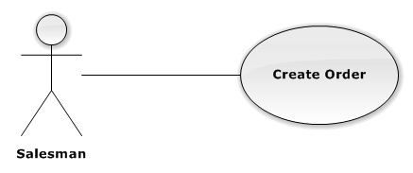

**Figure 3-18: Create Order Use-Case Diagram**

##### Use-Case Specification

|  |  |  |  |
| --- | --- | --- | --- |
| USE CASE SPECIFICATION | | | |
| Use-case No. | UC0001 | Use-case Version | 1.0 |
| Use-case Name | Register | | |
| Author | TungTD | | |
| Date | 10/10/2015 | Priority | Normal |
| Actor:  Guest.  Summary:  This Use Case help Guest to create an account in the system.  **Goal:**  Help Guest can have an account in the system. Guest can use this account to login the system and post their request.  Triggers:  Guest go to Homepage and click on “Tạo tài khoản” link.  Preconditions:  Guest does not have an account in system.  Post Conditions:  User Homepage display.  Main Success Scenario:   |  |  |  | | --- | --- | --- | | Step | Actor | Action | | 1 | User | Guest go to Homepage and clicks on “Đăng Kí” | | 2 | System | Display “Register” screen with text box for guest input all necessary to create new account | | 3 | User | Input all required field | | 4 | System | Validate all input date. Send invalid message (if have invalid data) | | 5 | User | Guest click on “Đồng ý” button (Correct all invalid fields if have any invalid data) | | 6 | System | System creates new account for guest | | 7 | System | Redirect to User Homepage |   Alternative Scenario:   |  |  |  | | --- | --- | --- | | # | Actor | Action | | 1 | User | Click on “Hủy” button | | System | System redirect to Homepage |   Exceptions:   |  |  |  | | --- | --- | --- | | # | User | System | | 1 | User | Not input enough information required | | System | Display message error: “Vui lòng điền thông tin vào những ô bắt buộc” |   Relationships:  “Login” use case.  Business Rules:   |  |  | | --- | --- | | # | Business Rule Description | | 1 | Guest must be enter all required fields before submitting. | | 2 | Each register, guest can create one account in the system | | 3 | Each Drugstore’s info, there is only one account. | | 4 | Each account in the system is distinguished by e-mail address. | | 5 | When e-mail fields of the new account are the same as the existing ones, system will show invalid message. | | | | |

#### UC0018 “Salesman” View Order

##### Use-Case Diagram

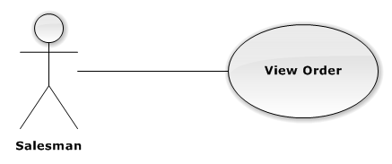

**Figure 3-19: Register Use-Case Diagram**

##### Use-Case Specification

|  |  |  |  |
| --- | --- | --- | --- |
| USE CASE SPECIFICATION | | | |
| Use-case No. | UC0018 | Use-case Version | 1.0 |
| Use-case Name | View all Order | | |
| Author | TungTD | | |
| Date | 10/10/2015 | Priority | Normal |
| Actor:  Salesman.  Summary:  This Use Case help Salesman can view all Order from Drugstore.  **Goal:**  Help Salesman view all Order from their Drugstore they Manage.  Triggers:  Salesman click on “Xem danh sách đơn hàng” link.  Preconditions:  User has logged in System with Salesman role.  Post Conditions:  User Homepage display.  Main Success Scenario:   |  |  |  | | --- | --- | --- | | Step | Actor | Action | | 1 | User | Clicks on “Danh sách đơn hàng” on User Control Panel. | | 2 | System | Display View Order screen. |   Alternative Scenario:  N/A  Exceptions:  N/A  Relationships:  N/A  Business Rules:   |  |  | | --- | --- | | # | Business Rule Description | | 1 | User has logged in with Salesman role. | | 2 | Needed Internet Access. | | | | |

#### UC0019 “Salesman” View Order Detail

##### Use-Case Diagram

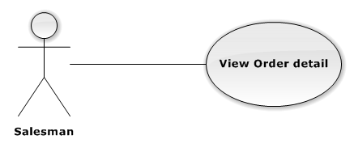

**Figure 3-20: View Order detail Use-Case Diagram**

##### Use-Case Specification

|  |  |  |  |
| --- | --- | --- | --- |
| USE CASE SPECIFICATION | | | |
| Use-case No. | UC0019 | Use-case Version | 1.0 |
| Use-case Name | View Order detail | | |
| Author | TungTD | | |
| Date | 10/10/2015 | Priority | Normal |
| Actor:  Salesman.  Summary:  This Use Case help Salesman view Detail of an Order.  **Goal:**  Help Guest can view all Detail of an Order from Drugstore.  Triggers:  Guest go to “Danh sách đơn hàng” page.  Preconditions:  User has logged in with Salesman role.  View Order Page has at least 1 Order.  Post Conditions:  Show Order Detail.  Main Success Scenario:   |  |  |  | | --- | --- | --- | | Step | Actor | Action | | 1 | User | Guest go to “Danh sách đơn hàng” and clicks on “Xem chi tiết”. | | 2 | System | Display View Detail screen. |   Alternative Scenario:  N/A  Exceptions:  N/A  Relationships:  N/A  Business Rules:   |  |  | | --- | --- | | # | Business Rule Description | | 1 | User has logged in with Salesman role. | | 2 | Needed Internet Access. | | | | |

#### UC0020 “Salesman” Set Discount Rate

##### Use-Case Diagram

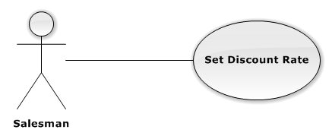

**Figure 3-21: Set Discount Rate Use-Case Diagram**

##### Use-Case Specification

|  |  |  |  |
| --- | --- | --- | --- |
| USE CASE SPECIFICATION | | | |
| Use-case No. | UC0020 | Use-case Version | 1.0 |
| Use-case Name | Set Discount Rate | | |
| Author | TungTD | | |
| Date | 10/10/2015 | Priority | Normal |
| Actor:  Salesman, Staff.  Summary:  This Use Case help set Discount Rate for Drug.  **Goal:**  Help Salesman and Staff Set Discount Rate for each Drug Product.  Triggers:  User go to [DrugDetail] page.  Preconditions:  User has logged in with Salesman or Staff role.  There are least 1 Drug Product in system.  Post Conditions:  Discount Rate Set successful.  Main Success Scenario:   |  |  |  | | --- | --- | --- | | Step | Actor | Action | | 1 | User | Guest go to [DrugDetail] page and clicks on “Chiết khấu” | | 2 | System | Discount Rate change. |   Alternative Scenario:  N/A  Exceptions:  N/A  Relationships:  N/A  Business Rules:   |  |  | | --- | --- | | # | Business Rule Description | | 1 | User has logged in with Salesman or Staff role. | | 2 | There are least 1 Drug in System. | | | | |

#### UC0021 “Staff” Approve Order

##### Use-Case Diagram

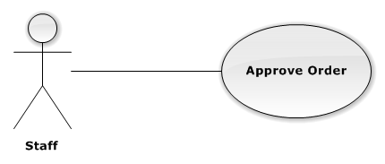

**Figure 3-22: Approve Use-Case Diagram**

##### Use-Case Specification

|  |  |  |  |
| --- | --- | --- | --- |
| USE CASE SPECIFICATION | | | |
| Use-case No. | UC0021 | Use-case Version | 1.0 |
| Use-case Name | Approve Order | | |
| Author | TungTD | | |
| Date | 10/10/2015 | Priority | Normal |
| Actor:  Staff.  Summary:  This Use Case help Staff confirm Order request form Drugstore.  **Goal:**  Help Staff confirm Order from Drugstore and Delivery for them.  Triggers:  Staff go to [ViewOrder] page and click on [Xác Nhận] button.  Preconditions:  There are least 1 pending Order.  Post Conditions:  Order change to Confirmed status.  Main Success Scenario:   |  |  |  | | --- | --- | --- | | Step | Actor | Action | | 1 | User | Go to [ViewOrder] page and click on [Xác nhận] button. | | 2 | System | Confirm order and change status to “Đã Xác Nhận”. |   Alternative Scenario:  N/A  Exceptions:  N/A  Relationships:  N/A  Business Rules:   |  |  | | --- | --- | | # | Business Rule Description | | 1 | At least 1 Pending Order exists in System. | | 2 | Needed Internet Access. | | | | |

#### UC0022 “Staff” Add New Drug

##### Use-Case Diagram

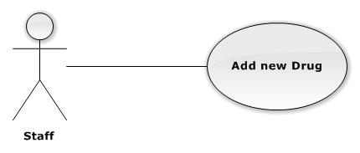

**Figure 3-23: Add new Drug Use-Case Diagram**

##### Use-Case Specification

|  |  |  |  |
| --- | --- | --- | --- |
| USE CASE SPECIFICATION | | | |
| Use-case No. | UC0022 | Use-case Version | 1.0 |
| Use-case Name | Add new Drug | | |
| Author | TungTD | | |
| Date | 10/10/2015 | Priority | Normal |
| Actor:  Staff.  Summary:  This Use Case help Staff can Add new Drug.  **Goal:**  Help Staff Add new Drug to System.  Triggers:  Guest go to [ManageDrug] Page and click on [Thêm mới thuốc] button.  Preconditions:  User has logged in System with Staff role.  Post Conditions:  Drug added to system successful.  Main Success Scenario:   |  |  |  | | --- | --- | --- | | Step | Actor | Action | | 1 | User | Guest go to [ManageDrug] page and clicks on [Thêm mới thuốc] button. | | 2 | System | Display all required information Drug field. | | 3 | User | Input all required field. | | 4 | System | Valid all input field and Add new Drug to database. Display message “Thêm mới thuốc thành công”. |   Alternative Scenario:   |  |  |  | | --- | --- | --- | | # | Actor | Action | | 1 | User | Click on “Hủy” button | | System | Back to [ManageDrug] page |   Exceptions:   |  |  |  | | --- | --- | --- | | # | User | System | | 1 | User | Not input enough information required | | System | Display message error: “Vui lòng điền thông tin vào những ô bắt buộc” |   Relationships:  “Login” use case.  Business Rules:   |  |  | | --- | --- | | # | Business Rule Description | | 1 | User has logged in with Staff role. | | 2 | Needed Internet Access. | | | | |

#### UC0023 “Staff” Delete Drug

##### Use-Case Diagram

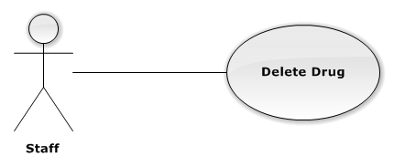

**Figure 3-24: Delete Drug Use-Case Diagram**

##### Use-Case Specification

|  |  |  |  |
| --- | --- | --- | --- |
| USE CASE SPECIFICATION | | | |
| Use-case No. | UC0023 | Use-case Version | 1.0 |
| Use-case Name | Delete Drug | | |
| Author | TungTD | | |
| Date | 10/10/2015 | Priority | Normal |
| Actor:  Staff.  Summary:  This Use Case help Staff delete Drug from System.  **Goal:**  Help Staff Delete unnecessary from System.  Triggers:  Staff go to [ViewDrugDetail] page or [ViewAllDrug] page.  Preconditions:  At least 1 Drug product exists in system.  Post Conditions:  Drug deleted from database.  Main Success Scenario:   |  |  |  | | --- | --- | --- | | Step | Actor | Action | | 1 | User | Staff go to [ViewDrugDetail] page or [ViewAllDrug] page and click on [Xóa] button. | | 2 | System | Display message “Bạn muốn xóa sản phẩm này?” | | 3 | User | Click on “Xác nhận” | | 4 | System | Delete Drug from database and display message “Đã xóa thành công”. |   Alternative Scenario:   |  |  |  | | --- | --- | --- | | # | Actor | Action | | 1 | User | Click on “Hủy” button. | | System | System redirect to Previous page. |   Exceptions:  N/A  Relationships:  N/A  Business Rules:   |  |  | | --- | --- | | # | Business Rule Description | | 1 | At least 1 Drug product exists in System. | | 2 | Needed Internet Access. | | | | |

#### UC0024 “Staff” Edit Drug

##### Use-Case Diagram

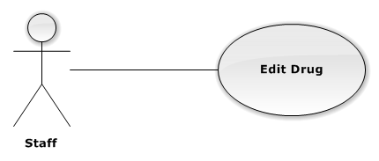

**Figure 3-25: Edit Drug Use-Case Diagram**

##### Use-Case Specification

|  |  |  |  |
| --- | --- | --- | --- |
| USE CASE SPECIFICATION | | | |
| Use-case No. | UC0024 | Use-case Version | 1.0 |
| Use-case Name | Edit Drug | | |
| Author | TungTD | | |
| Date | 10/10/2015 | Priority | Normal |
| Actor:  Staff.  Summary:  This Use Case help Staff edit Drug.  **Goal:**  Help Staff can update lastest information about Drug.  Triggers:  Staff go to [ManageDrug] Page.  Preconditions:  At least 1 Drug exists in System.  User has logged in with Staff role.  Post Conditions:  Update information Drug to database successfull.  Main Success Scenario:   |  |  |  | | --- | --- | --- | | Step | Actor | Action | | 1 | User | Staff go to [ViewDrugDetail] page or [ViewAllDrug] page and click on [Chỉnh sửa] button. | | 2 | System | Display all required field. | | 3 | User | Input all required field | | 4 | System | Validate all input date. Send invalid message (if have invalid data) | | 5 | User | Guest click on “Đồng ý” button (Correct all invalid fields if have any invalid data) | | 6 | System | Update database and display message “Cập nhật thành công” | | 7 | System | Go back to Previous page. |   Alternative Scenario:   |  |  |  | | --- | --- | --- | | # | Actor | Action | | 1 | User | Click on “Hủy” button | | System | Go back to Previous Page |   Exceptions:   |  |  |  | | --- | --- | --- | | # | User | System | | 1 | User | Not input enough information required | | System | Display message error: “Vui lòng điền thông tin vào những ô bắt buộc” |   Relationships:  N/A.  Business Rules:   |  |  | | --- | --- | | # | Business Rule Description | | 1 | At least 1 Drug exists in System. | | 2 | Needed Internet Access. | | | | |

#### UC0025 “Staff” Assign Salesman

##### Use-Case Diagram

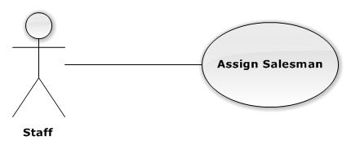

**Figure 3-26: Assign Salesman Use-Case Diagram**

##### Use-Case Specification

|  |  |  |  |
| --- | --- | --- | --- |
| USE CASE SPECIFICATION | | | |
| Use-case No. | UC0025 | Use-case Version | 1.0 |
| Use-case Name | Register | | |
| Author | TungTD | | |
| Date | 10/10/2015 | Priority | Normal |
| Actor:  Staff.  Summary:  This Use Case help Staff assign Salesman to group they manage.  **Goal:**  Help Salesman manage their Drugstore easier.  Triggers:  Staff choose a Salesman and assign to group.  Preconditions:  At least 1 Salesman exists in System.  At least 1 Group exists in System.  Post Conditions:  Salesman assigned to Group.  Main Success Scenario:   |  |  |  | | --- | --- | --- | | Step | Actor | Action | | 1 | User | Choose a Salesman and assign to any Group they want. | | 2 | System | Display message “Bạn có muốn chỉ định nhân viên tiếp thị [UserName] quản lý nhóm của hàng [NameGroup]?”. | | 3 | User | Click on [Xác nhận] button. | | 4 | System | Assign Salesman to Group and Display message “Đã chỉ định thành công” |   Alternative Scenario:   |  |  |  | | --- | --- | --- | | # | Actor | Action | | 1 | User | Click on “Hủy” button | | System | System redirect to Previous Page |   Exceptions:  N/A  Relationships:  N/A  Business Rules:   |  |  | | --- | --- | | # | Business Rule Description | | 1 | At least 1 Salesman exists in System. | | 2 | At least 1 Group exist in System. | | 3 | Needed Internet Access. | | | | |

#### UC0026 “Staff” Create Category

##### Use-Case Diagram

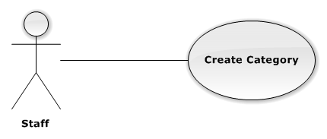

**Figure 3-27: Create Category Use-Case Diagram**

##### Use-Case Specification

|  |  |  |  |
| --- | --- | --- | --- |
| USE CASE SPECIFICATION | | | |
| Use-case No. | UC0026 | Use-case Version | 1.0 |
| Use-case Name | Create Category | | |
| Author | TungTD | | |
| Date | 10/10/2015 | Priority | Normal |
| Actor:  Staff.  Summary:  This Use Case help Staff Create Category to System.  **Goal:**  Help Staff Create Category to System, easily to Group Drug.  Triggers:  Go to [ManageCategory] page.  Preconditions:  User has logged in with Staff role.  Post Conditions:  Category Created.  Main Success Scenario:   |  |  |  | | --- | --- | --- | | Step | Actor | Action | | 1 | User | Staff go to [ManageCategory] and click on “Tạo mới danh mục thuốc”. | | 2 | System | Display [AddNewCategory] screen with text box for guest input all necessary field. | | 3 | User | Input all required field | | 4 | System | Validate all input date. Send invalid message (if have invalid data) | | 5 | User | Guest click on “Đồng ý” button. | | 6 | System | Create new Category to database and Display message “Tạo mới thành công” | | 7 | System | Go back to Previous Page |   Alternative Scenario:   |  |  |  | | --- | --- | --- | | # | Actor | Action | | 1 | User | Click on “Hủy” button | | System | System redirect to Previous Page |   Exceptions:   |  |  |  | | --- | --- | --- | | # | User | System | | 1 | User | Not input enough information required | | System | Display message error: “Vui lòng điền thông tin vào những ô bắt buộc” |   Relationships:  N/A  Business Rules:   |  |  | | --- | --- | | # | Business Rule Description | | 1 | User has logged in with Staff role. | | 2 | Needed Internet Access. | | | | |

#### UC0027 “Staff” Delete Category

##### Use-Case Diagram

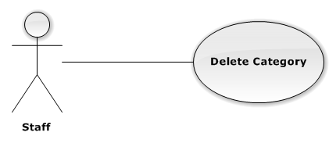

**Figure 3-28: Delete Category Use-Case Diagram**

##### Use-Case Specification

|  |  |  |  |
| --- | --- | --- | --- |
| USE CASE SPECIFICATION | | | |
| Use-case No. | UC0027 | Use-case Version | 1.0 |
| Use-case Name | Delete Category | | |
| Author | TungTD | | |
| Date | 10/10/2015 | Priority | Normal |
| Actor:  Staff.  Summary:  This Use Case help Staff Delete a Category.  **Goal:**  Help Staff can Delete an unnecessary Category form system.  Triggers:  Staff go to [MangeCategory] page.  Preconditions:  Guest does not have an account in system.  Post Conditions:  User Homepage display.  Main Success Scenario:   |  |  |  | | --- | --- | --- | | Step | Actor | Action | | 1 | User | Go to [ManageCategory] page and click on [Xóa] button on the right side of [CategoryName]. | | 2 | System | Display message “Bạn muốn xóa danh mục này?” | | 3 | User | Click on [Xác nhận] button. | | 4 | System | Delete from database and display message “Xóa thành công”. | | 5 | System | Redirect to Previous Page. |   Alternative Scenario:   |  |  |  | | --- | --- | --- | | # | Actor | Action | | 1 | User | Click on “Hủy” button. | | System | System redirect to Previous Page. |   Exceptions:  N/A  Relationships:  N/A  Business Rules:   |  |  | | --- | --- | | # | Business Rule Description | | 1 | User has logged in with Staff role. | | 2 | At least 1 Category exists in System. | | | | |

#### UC0028 “Staff” Edit Category

##### Use-Case Diagram

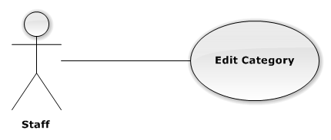

**Figure 3-29: Edit Category Use-Case Diagram**

##### Use-Case Specification

|  |  |  |  |
| --- | --- | --- | --- |
| USE CASE SPECIFICATION | | | |
| Use-case No. | UC0028 | Use-case Version | 1.0 |
| Use-case Name | Edit Category | | |
| Author | TungTD | | |
| Date | 10/10/2015 | Priority | Normal |
| Actor:  Staff.  Summary:  This Use Case allow Staff edit information of Category.  **Goal:**  Help Staff update latest information about Category.  Triggers:  Staff go to [MangeCategory] page.  Preconditions:  At least 1 Category exists in System.  Post Conditions:  Category information Updated.  Main Success Scenario:   |  |  |  | | --- | --- | --- | | Step | Actor | Action | | 1 | User | Go to [ManageCategory] page and click on [Sửa] button on the right side of [CategoryName]. | | 2 | System | Display [EditCategory] page with text box for guest input all necessary field. | | 3 | User | Input all required field | | 4 | System | Validate all input data. | | 5 | User | Guest click on “Đồng ý” button. | | 6 | System | Display message “Cập nhật thành công” | | 7 | System | Redirect to Previous page |   Alternative Scenario:   |  |  |  | | --- | --- | --- | | # | Actor | Action | | 1 | User | Click on “Hủy” button | | System | System redirect to Previous page. |   Exceptions:   |  |  |  | | --- | --- | --- | | # | User | System | | 1 | User | Not input enough information required | | System | Display message error: “Vui lòng điền thông tin vào những ô bắt buộc” |   Relationships:  N/A  Business Rules:   |  |  | | --- | --- | | # | Business Rule Description | | 1 | User has logged in with Staff role. | | 2 | At least 1 Category exists in System. | | 3 | Needed Internet Access. | | | | |

#### UC0029 “Staff” Create Delivery Schedule

##### Use-Case Diagram

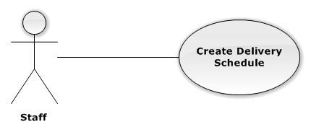

**Figure 3-30: Create Delivery Use-Case Diagram**

##### Use-Case Specification

|  |  |  |  |
| --- | --- | --- | --- |
| USE CASE SPECIFICATION | | | |
| Use-case No. | UC0029 | Use-case Version | 1.0 |
| Use-case Name | Create Delivery Schedule | | |
| Author | TungTD | | |
| Date | 10/10/2015 | Priority | Normal |
| Actor:  Staff.  Summary:  This Use Case help Staff Create delivery schedule.  **Goal:**  Help Deliveryman move in shortest path and exactly address.  Triggers:  Go to [ManageSchedule] page.  Preconditions:  At least 1 Confirmed Order exists in system.  Post Conditions:  *On success:* Delivery schedule created.  Main Success Scenario:   |  |  |  | | --- | --- | --- | | Step | Actor | Action | | 1 | User | Staff go to [ManageSchedule] click on [Tạo lịch giao hàng] button. | | 2 | System | Show all Confirm order. | | 3 | User | Choose Delivery man. | | 4 | System | Delivery Schedule created. |   Alternative Scenario:   |  |  |  | | --- | --- | --- | | # | Actor | Action | | 1 | User | Click on “Hủy” button | | System | System redirect to Previous page. |   Exceptions:  N/A  Relationships:  N/A  Business Rules:   |  |  | | --- | --- | | # | Business Rule Description | | 1 | At least 1 Confirmed exists in System. | | 2 | Needed Internet Access. | | | | |

#### UC0030 “Staff” Update Delievery Status

##### Use-Case Diagram



**Figure 3-31: Update Delivery Status Use-Case Diagram**

##### Use-Case Specification

|  |  |  |  |
| --- | --- | --- | --- |
| USE CASE SPECIFICATION | | | |
| Use-case No. | UC0030 | Use-case Version | 1.0 |
| Use-case Name | Update delivery status | | |
| Author | TungTD | | |
| Date | 10/10/2015 | Priority | Normal |
| Actor:  Staff.  Summary:  This Use Case help Staff update Delivery status in system.  **Goal:**  Help Drugstore know their order status.  Triggers:  Staff go to [ManageSchedule] page.  Preconditions:  Guest does not have an account in system.  Post Conditions:  User Homepage display.  Main Success Scenario:   |  |  |  | | --- | --- | --- | | Step | Actor | Action | | 1 | User | Guest go to Homepage and clicks on [Hoàn thành] button. | | 2 | System | Change Order status “Hoàn thành”. |   Alternative Scenario:  N/A  Exceptions:  N/A  Relationships:  N/A  Business Rules:   |  |  | | --- | --- | | # | Business Rule Description | | 1 | Needed Internet Access. | | | | |

#### UC0031 “Administrator” Create New Account

##### Use-Case Diagram

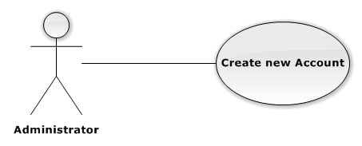

**Figure 3-35: Create New Account Use-Case Diagram**

##### Use-Case Specification

|  |  |  |  |
| --- | --- | --- | --- |
| USE CASE SPECIFICATION | | | |
| Use-case No. | UC0031 | Use-case Version | 1.0 |
| Use-case Name | Create Account | | |
| Author | TungTD | | |
| Date | 10/10/2015 | Priority | Normal |
| Actor:  Administrator.  Summary:  This Use Case help Admin Create Account.  **Goal:**  Help Staff, Salesman have account in system.  Triggers:  Go to [ManageAccount] page.  Preconditions:  Admin has logged in to System.  Post Conditions:  Account Created.  Main Success Scenario:   |  |  |  | | --- | --- | --- | | Step | Actor | Action | | 1 | User | Admin go to [ManageAccount] page and click on [Tạo tài khoản] button. | | 2 | System | Display [CreateAccount] screen with text box for Admin input all necessary to create new account. | | 3 | User | Input all required field | | 4 | System | Validate all input date. Send invalid message (if have invalid data) | | 5 | User | Admin click on [Xác nhận] button. | | 6 | System | System creates new account. | | 7 | System | Redirect to Previous page. |   Alternative Scenario:   |  |  |  | | --- | --- | --- | | # | Actor | Action | | 1 | User | Click on “Hủy” button | | System | System redirect to Previous Page. |   Exceptions:   |  |  |  | | --- | --- | --- | | # | User | System | | 1 | User | Not input enough information required | | System | Display message error: “Vui lòng điền thông tin vào những ô bắt buộc” |   Relationships:  “Login” use case.  Business Rules:   |  |  | | --- | --- | | # | Business Rule Description | | 1 | User has logged in system with Admin role. | | 2 | Need Internet Access. | | | | |

#### UC0032 “Administrator” Deactivate Account

##### Use-Case Diagram

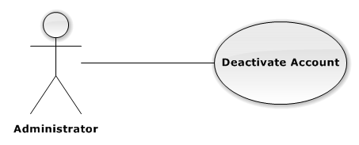

**Figure 3-36: Deactivate Account Use-Case Diagram**

##### Use-Case Specification

|  |  |  |  |
| --- | --- | --- | --- |
| USE CASE SPECIFICATION | | | |
| Use-case No. | UC0032 | Use-case Version | 1.0 |
| Use-case Name | Register | | |
| Author | TungTD | | |
| Date | 10/10/2015 | Priority | Normal |
| Actor:  Administrator.  Summary:  This Use Case help Admin ban Account in system.  **Goal:**  Help Admin deactivate account in system.  Triggers:  Admin go to [ManageAccount] page.  Preconditions:  At least 1 account exists in System.  Post Conditions:  Account has Deactivated.  Main Success Scenario:   |  |  |  | | --- | --- | --- | | Step | Actor | Action | | 1 | User | Admin go to [ManageAccount] and click on [Deactivate] button on the right of [AccountName]. | | 2 | System | Deactivated account and change status to “Deactivated” |   Alternative Scenario:  N/A  Exceptions:  N/A  Relationships:  N/A  Business Rules:   |  |  | | --- | --- | | # | Business Rule Description | | 1 | At least 1 Active Account exists in System. | | 2 | Needed Internet Access. | | | | |

#### UC0033 “Administrator” Activate Account

##### Use-Case Diagram

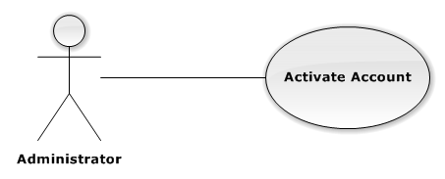

**Figure 3-37: Activate Account Use-Case Diagram**

##### Use-Case Specification

|  |  |  |  |
| --- | --- | --- | --- |
| USE CASE SPECIFICATION | | | |
| Use-case No. | UC0033 | Use-case Version | 1.0 |
| Use-case Name | Register | | |
| Author | TungTD | | |
| Date | 10/10/2015 | Priority | Normal |
| Actor:  Administrator.  Summary:  This Use-Case allow Admin re-activate account.  **Goal:**  Help Deactivated account change to activate status.  Triggers:  Admin go to [ManageAccount] page.  Preconditions:  At least 1 Deactivated Account exists in System.  Post Conditions:  Activate Account.  Main Success Scenario:   |  |  |  | | --- | --- | --- | | Step | Actor | Action | | 1 | User | Admin go to [ManageAccount] and click on [Activate] button on the right side of [AccountName]. | | 2 | System | Re-Active account and change status to Active. |   Alternative Scenario:  N/A  Exceptions:  N/A  Relationships:  N/A  Business Rules:   |  |  | | --- | --- | | # | Business Rule Description | | 1 | At least 1 Deactivated Account exists in System. | | 2 | Needed Internet Access. | | | | |

### Non-functional Requirements

#### Reliability

Information about drug are provided by Staff in such a way that preserves the most accurate and up-to-date data.

#### Security

Authentication is required when the user utilizes certain function in system. Password must be encrypted so the even they are unrecognizable even to System Administrator and Database Administrator. System should also require authorization when user tries to access an unauthorized function.

#### Maintainability

In the architecture design of the system, the responsibilities of all component should be clear and do not overlap each other. The communication with a web service provider should be packaged in single module independent from the rest of the system. The module should support plug-and-play, so when the web service provider change the structure of web service result, or when system work with other web service provider. Minimal changes to rest of system are required.

## Entity Relationship Diagram

